- Search and circle the words in the grid.

W E G N D W O O D M I N
O T R O P D U I B U S H
T R A J R O O T Y I I I
R E S E E D S R I T T I
K E S F H T U I K P U I
L E A F J U K I M O S S
I N S E C T H O B A R K

- WOOD - DREWNO
- TREE - DRZEWO
- LEAF - LIŚĆ
- INSECT - OWAD
- BARK - KORA
- GRASS - TRAWA
- SEEDS - NASIONA
- ROOT - KORZEŃ
- MOSS - MECH
- BUSH - KRZAK

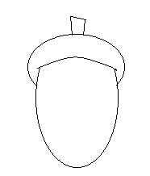
2. What is this?

This is ACORN.

